**Variability of the ocean carbon sink in MPI-ESM large ensemble simulations**

Hongmei Li1, Tatiana Ilyina1

1 Max Planck Institute for Meteorology, Bundesstraße 53, 20146 Hamburg, Germany.

Corresponding author: Hongmei Li ([hongmei.li@mpimet.mpg.de)](mailto:email@address.edu))

Key Points:

* Large internal variability of the oceanic carbon uptake.
* Large ensemble simulations are required to reproduce the internal variability of oceanic carbon uptake.
* The internal variability of oceanic carbon uptake would increase with increasing of atmospheric CO2 emissions.

Abstract

The world oceans are major carbon sink and play a major role in modulating global warming, however, the contribution of internal model variability to the uncertainty in the oceanic carbon uptake remains unclear. By using a large ensemble simulation of (a) 100 ensemble members of historical and RCP4.5 simulation (1850-2035) and (b) 68 ensemble members of 1% per year CO2 increase up to 4xCO2 level simulation (155 years) based on the Max Planck Institute Earth System Model (MPI-ESM), we investigate the internal variability of the oceanic carbon uptake. Large internal variability of the oceanic carbon uptake is found among the ensemble simulations, both increasing and decreasing of 10-year trends are produced by the model. The Southern Ocean requires larger ensemble to produce the forced signal than the North Atlantic. The internal variability of oceanic carbon uptake may increase in future high CO2 concentration world.

1 Introduction

The oceans are major carbon sink by taking up about 25-30% of the anthropogenic carbon emissions from the atmosphere [*C. Le Quéré et al.*, 2015]. The strength of ocean carbon sink determines the proportional carbon remaining in the atmosphere, and it further modulates climate change. Previous studies based on observations reveals that the evolution of oceanic carbon sink shows large variability in major carbon sink regions, i.e., the Southern Ocean [*Landschützer et al.*, 2015] and the North Atlantic [*Schuster and Watson*, 2007].

Large uncertainty of oceanic carbon uptake in the past decades is also found in data based estimates [*Rödenbeck et al.*, 2015]. Multi-model intercomparison exercises, such as Coupled Model Intercomparison Project Phase 5 (CMIP5) indicate that evolution of the global mean oceanic carbon uptake is quite robustly projected in the models. Yet, there are large regional discrepancies between different models and their origin is not well understood. Likewise, the contribution of internal model variability to the uncertainty in the oceanic carbon uptake remains unclear.

By using a large ensemble simulation based on the Max Planck Institute Earth System Model (MPI-ESM), we investigate the variability of the oceanic carbon uptake and try to answer the following questions: How large is the internal variability of oceanic carbon uptake in major carbon sink regions? How many ensemble members do we need to capture the forced trend / the internal variability? In a high CO2 concentration and warm world, will the internal variability of the oceanic carbon uptake be amplified accordingly?

2 Methods

2.1 Model description

The MPI-ESM version 1.1 with a low-resolution configuration (MPI-ESM-LR) is used for the large ensemble simulations. The ocean component is MPI Ocean Model (MPIOM) with horizontal resolution of 1.5° on average and 40 vertical levels [*Jungclaus et al.*, 2013]. The Hamburg Ocean Carbon Cycle Model (HAMOCC) [*Ilyina et al.*, 2013] represents the ocean biogeochmistry component of MPI-ESM. An ensemble of 100-member CMIP5 historical simulations and RCP4.5 scenario simulations are integrated for the periods from 1850-2005, and 2006-2035, respectively. In addition, an ensemble of 68-member CMIP5 idealized 1% per year CO2 increase up to 4xCO2 level simulation are integrated for 155 years. Ensemble members differ through starting from different year of the pre-industrial control simulation. This set of large ensemble simulations advanced our understanding of internal variability in atmosphere [*Stevens*, 2015] and ocean physical fields.

2.2 Data

For comparison with model simulations, we use 10 data-based estimates of global oceanic carbon flux from an international efforts of surface Ocean pCO2 mapping intercomparison [SOCOM, Rödenbeck et al., 2015]. All these data are based on the surface ocean CO2 atlas version 2 (SOCATv2) [Bakker et al., 2014] or Lamont-Doherty Earth Observatory version 2013 (LDEOv2013) [*Takahashi et al.*, 2014] databases, but using different method to fill the gap of measurement and to obtain a global coverage of ocean surface carbon uptake. Among these dataset, the ETH-SOMFFN data and its uncertainty [Landschützer et al., 2014; Landschützer et al., 2015] are used further to validate our model simulations of regional ocean carbon uptake in the Southern Ocean and the North Atlantic.

3 Historical evolution of ocean carbon sink

For the historical ocean carbon sink, we focus on recent 30 years (i.e., 1982-2011) when more ocean surface observation data are available. Fig. 1 shows the MPI-ESM 100-member historical simulations in the context of SOCOM products. Although an increasing trend dominents in the ensemble mean results, the oceanic carbon uptake shows large internal variability (i.e., spread of gray time series) in MPI-ESM simulations. In general, the magnitude of model ensemble spread is comparable to the discrepancy among SOCOM observation-based estimates.

Most SOCOM products produce a decreasing trend of ocean carbon sink in the 1990s. This is mainly due to the multi-year variations of oceanic carbon uptake in the North Atlantic and in the Southern Ocean [Landschützer et al., 2015; Schuster and Watson, 2007]. To investigate if some ensemble members could produce similar variability of ocean carbon sink as in the observation, we show the ocean carbon sink in the North Atlantic (Fig. 1b) and in the Southern Ocean (Fig. 1c). Here we use ETH-SOMFFN data as a reference, it shows obvious multi-year variation, especially in the Southern Ocean. The ocean carbon uptake in the Southern Ocean decreases in the 1990s, and it reinvigorates in the recent decade [*Landschützer et al.*, 2015]. The model simulation spread in both the North Atlantic and the Southern Ocean are the same magnitude as the uncertainty of ETH-SOMFFN data. We also calculate trend of all ensemble members in 3 consecutive periods, i.e., 1982-1991, 1992-2001, and 2002-2011. As shown with the red numbers in Fig. 1b-c, some ensemble members produce decreasing trend of ocean carbon sink for each 10-year time window. For instance, 35 and 25 ensemble members show decreasing trend of the ocean carbon sink during 1992-2001 in the North Atlantic and the Southern Ocean, respectively. The 5-95% range of 10-year trend is about 0.07 (larger than 0.5) PgC yr-1 per decadein the North Atlantic (Southern Ocean) (see Table S1).

In general, the internal variability of ocean carbon sink is large. As shown in [*McKinley et al.*, 2016], it is challenging to detect future anthropogenic emission induced trend of ocean carbon uptake, and the internal variability varies with regions.

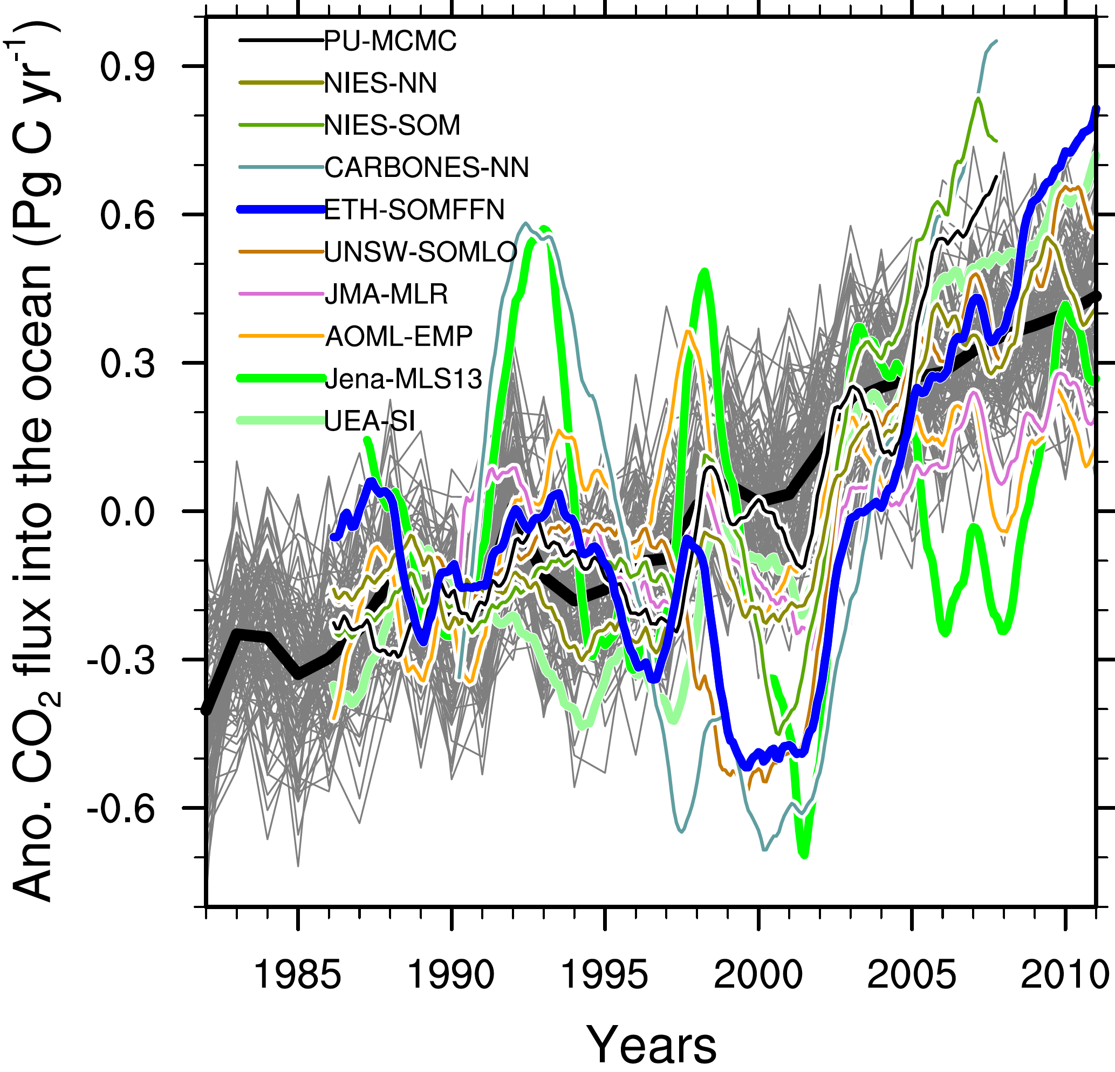

**(a)**

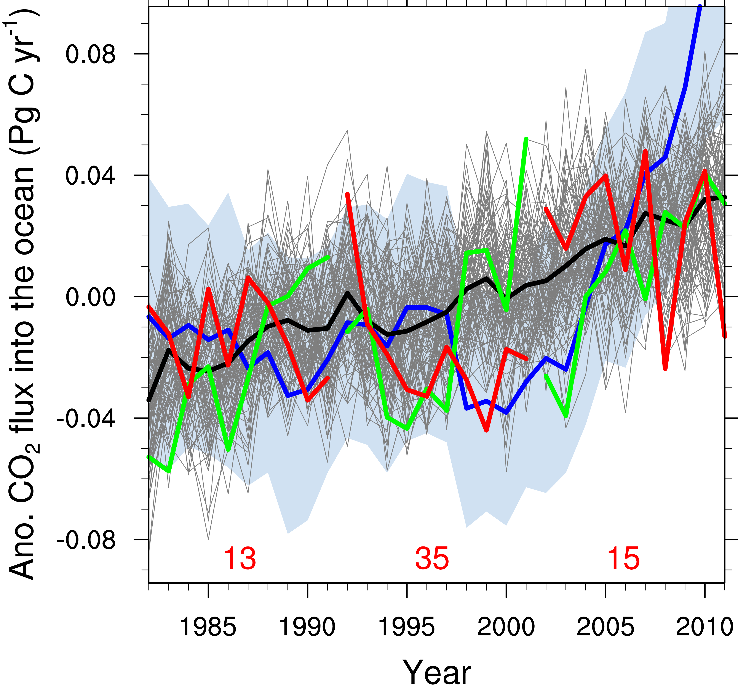

**(b)**

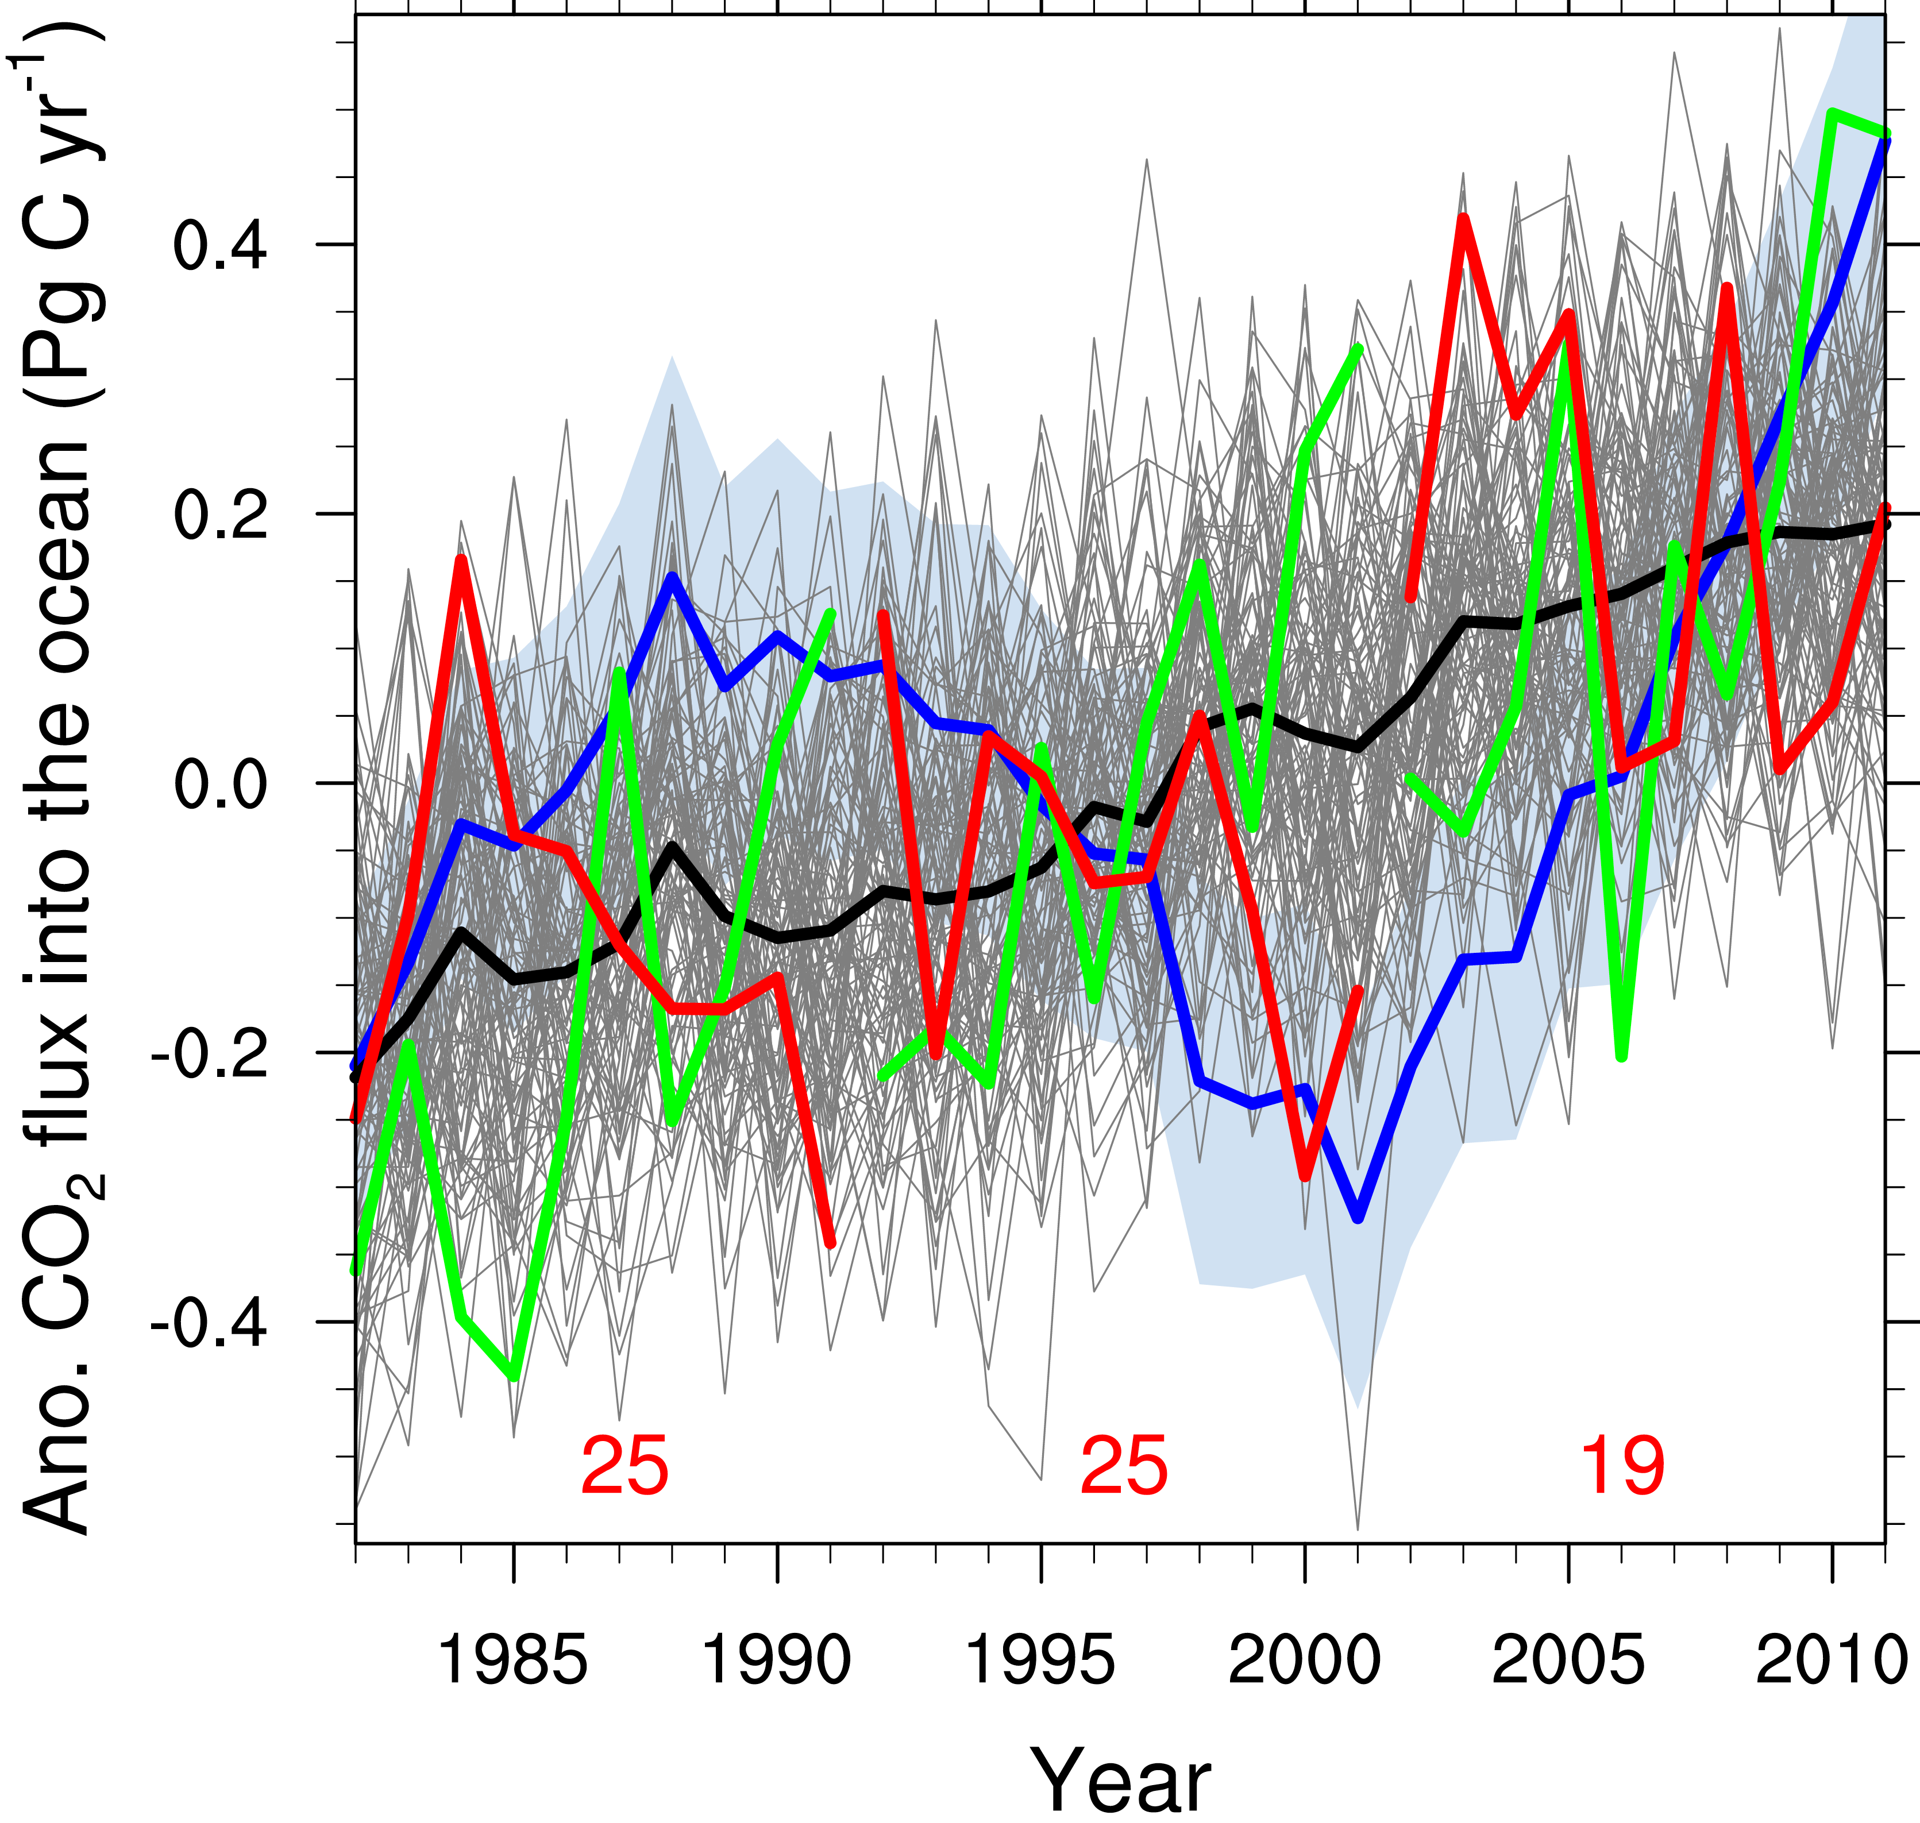

**(c)**

Fig 1. Historical evolution of anomalous ocean carbon sink from data-based estimates and MPI-ESM large ensemble simulations. Time series in global, North Atlantic, and Southern Ocean are shown in (a), (b), and (c), respectively. The grey lines show individual ensemble members and black thick line shows ensemble mean. Color lines with legend in (a) shows 10 data-based estimates from different methods [SOCOM, *Rödenbeck et al.*, 2015]. The blue lines and shading in (b)-(c) show ETH-SOMFFN data and its uncertainty [*Landschützer et al.*, 2014; *Landschützer et al.*, 2015]. Red and green lines in (b)-(c) show members with the smallest and the largest trend in 3 consecutive decades, i.e., 1982-1991, 1992-2001, and 2002-2011. The red numbers show the number of ensemble members that produce negative trends in these 3 consecutive decades.

4 Spatial distribution of ocean carbon sink trend

For the spatial pattern, we show contrasting members regards to the short-term trend, i.e., 1992-2001. Single member and 10-member mean results with the maximum and minimum trends in the Southern Ocean are shown together with 100 member mean and standard deviation (Fig. 2). The same figure for the North Atlantic can be found in Fig. S1. The large member ensemble mean is defined as the ‘forced’ signal, and the difference between single member outcomes and the ensemble mean as internal variability or ‘unforced’ trend, respectively [Deser et al., 2014; Ting et al., 2009]. The ‘forced’ signals in both the North Atlantic and the Southern Ocean show dominant increasing trend. The ‘unforced’ trends show also large-scale spatial structure with some areas increasing trend and other areas decreasing trend. Moreover the magnitude of the unforced trend is as large as the forced trend. In the ensemble member with the minimum trend of Southern Ocean carbon uptake, the largest decreasing trend is along the latitude of 50-65°S where the Antarctic Circumpolar Current (ACC) is located. The largest increasing trend is also found in this latitude band in the ensemble member with the maximum trend of Southern Ocean carbon uptake. This reverse sign of trend in the ensemble members with maximum and minimum trends are even prominent in the 10-member ensemble mean results (see Fig. 2 b and d). Therefore, the largest internal variability is found in the 50-65°S band in the Southern Ocean (Fig. 2f). For the North Atlantic, the Labrado Sea is the area with the largest internal variability of oceanic carbon uptake (Fig. S1f).

As shown in previous studies [*Landschützer et al.*, 2015; *Corinne Le Quéré et al.*, 2009], the variations of oceanic carbon uptake are related to the background thermal and dynamic changes. Here we present trends of the sea level pressure, 10-meter wind, and ocean mixed layer thickness in corresponding to the maximum or minimum trend of oceanic carbon uptake in the North Atlantic and the Southern Ocean (see Fig. S2-3). The trend of wind and sea level pressure is reverse in the ensemble members with maximum trend and the ensemble members with mimum trend of oceanic carbon uptake, especially in the Southern Ocean. Reverse sign of trends in ocean mixed layer thickness is also found in the ensemble members. In the North Atlantic, prominent trends are found in the Labrador Sea, where is the same area of the largest internal variability of oceanic carbon uptake. In the Southern Ocean, prominent trends of ocean mixed layer thickness are found in the Weddell Sea and Ross Sea, where is to the south of the largest internal variability of oceanic carbon uptake.

To see how many ensemble members we need to detect the forced trend, we take the 100-member ensemble mean and standard deviation as references and calculate the spatial correlation of the trends from different size of ensemble members with the reference field (Fig. 3). The correlation increases with increasing of ensemble members. Regional comparison indicates that the Southern Ocean requires larger ensemble size than the North Atlantic to produce the 100-member ensemble mean trends (Fig. 3a). To produce the same correlation level of 0.8 with the reference field, the North Atlantic requires about 20 ensemble members, the Southern Ocean requires about 35 ensemble members. The needed ensemble size is larger probably due to larger internal variability in the Southern Ocean than in the North Atlantic. For producing the spread of the trends, it requires slightly larger ensemble size for the North Atlantic than the Southern Ocean (Fig. 3b). The curves increase in a larger slope in the trend spread correlation than the mean trend correlation, for ensemble size of 20, the correlations are even higher than 0.9. Therefore, it requires smaller ensemble size to reproduce the spread of trends than the mean of trends for shorter-term such as 10-year changes.

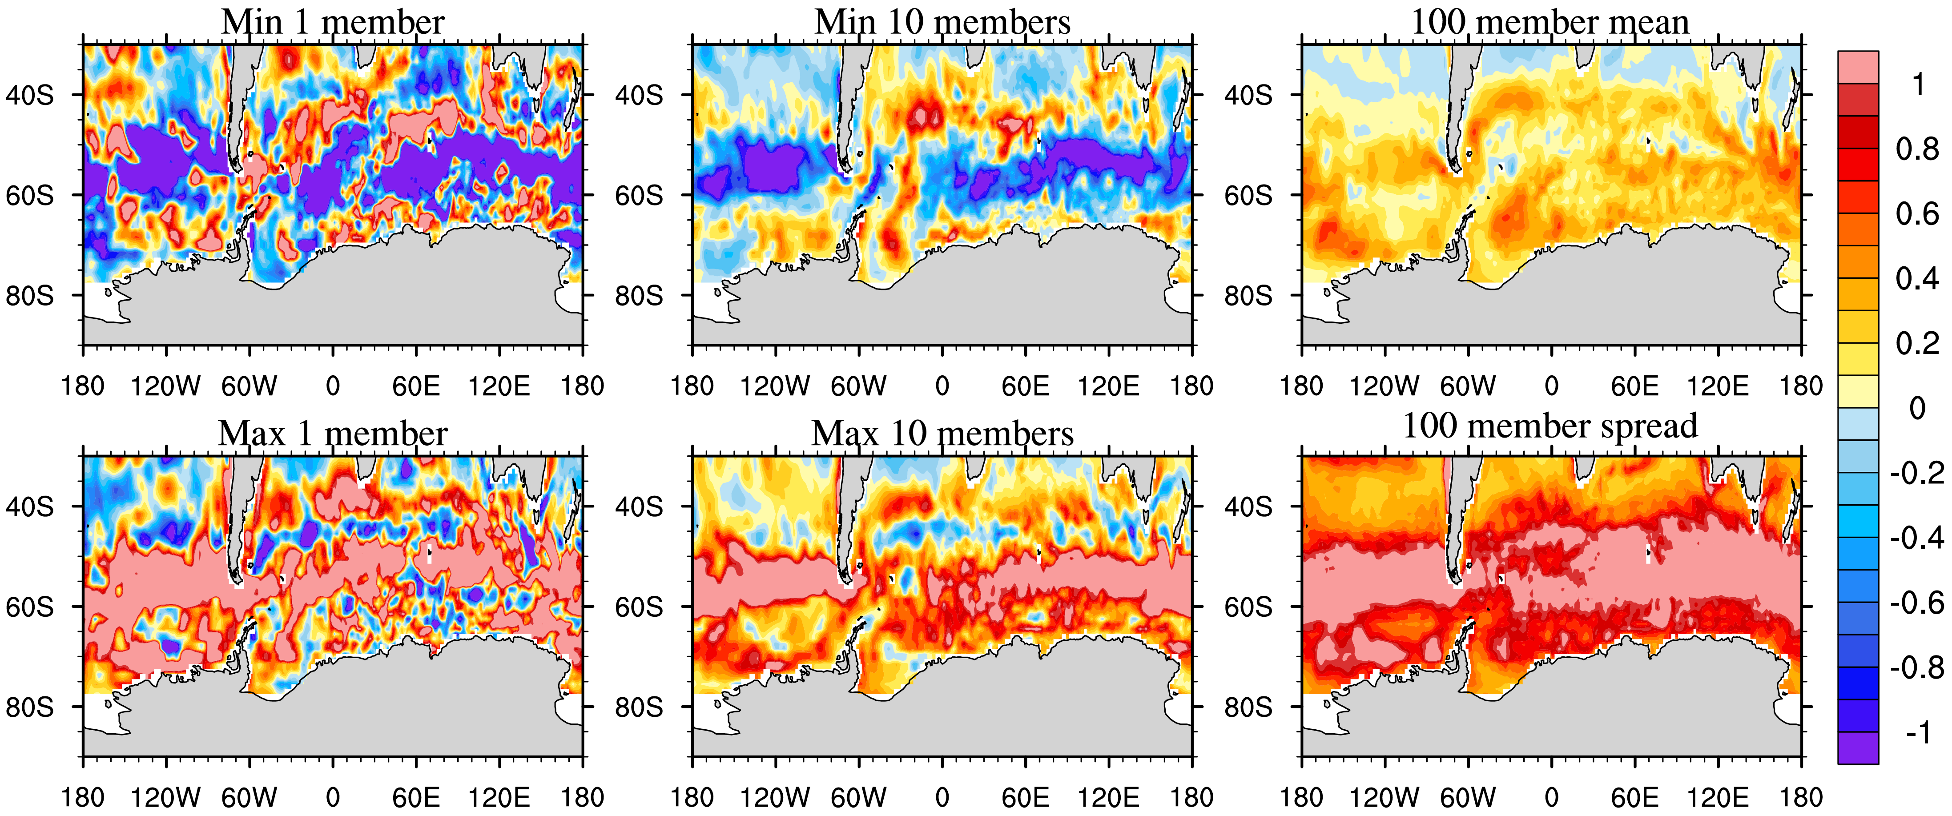

**(c)**

**(b)**

**(a)**

**(f)**

**(e)**

**(d)**

Fig 2. Members with contrasting trends of CO2 flux in the Southern Ocean during 1992-2001. The left column (a) and (d) shows the single member result with the minimum trend and the maximum trend, respectively. The middle column (b) and (e) shows 10-member ensemble mean result with the minimum trends and the maximum trends. The right column is 100-member ensemble mean (c) and standard deviation (f) of trend.

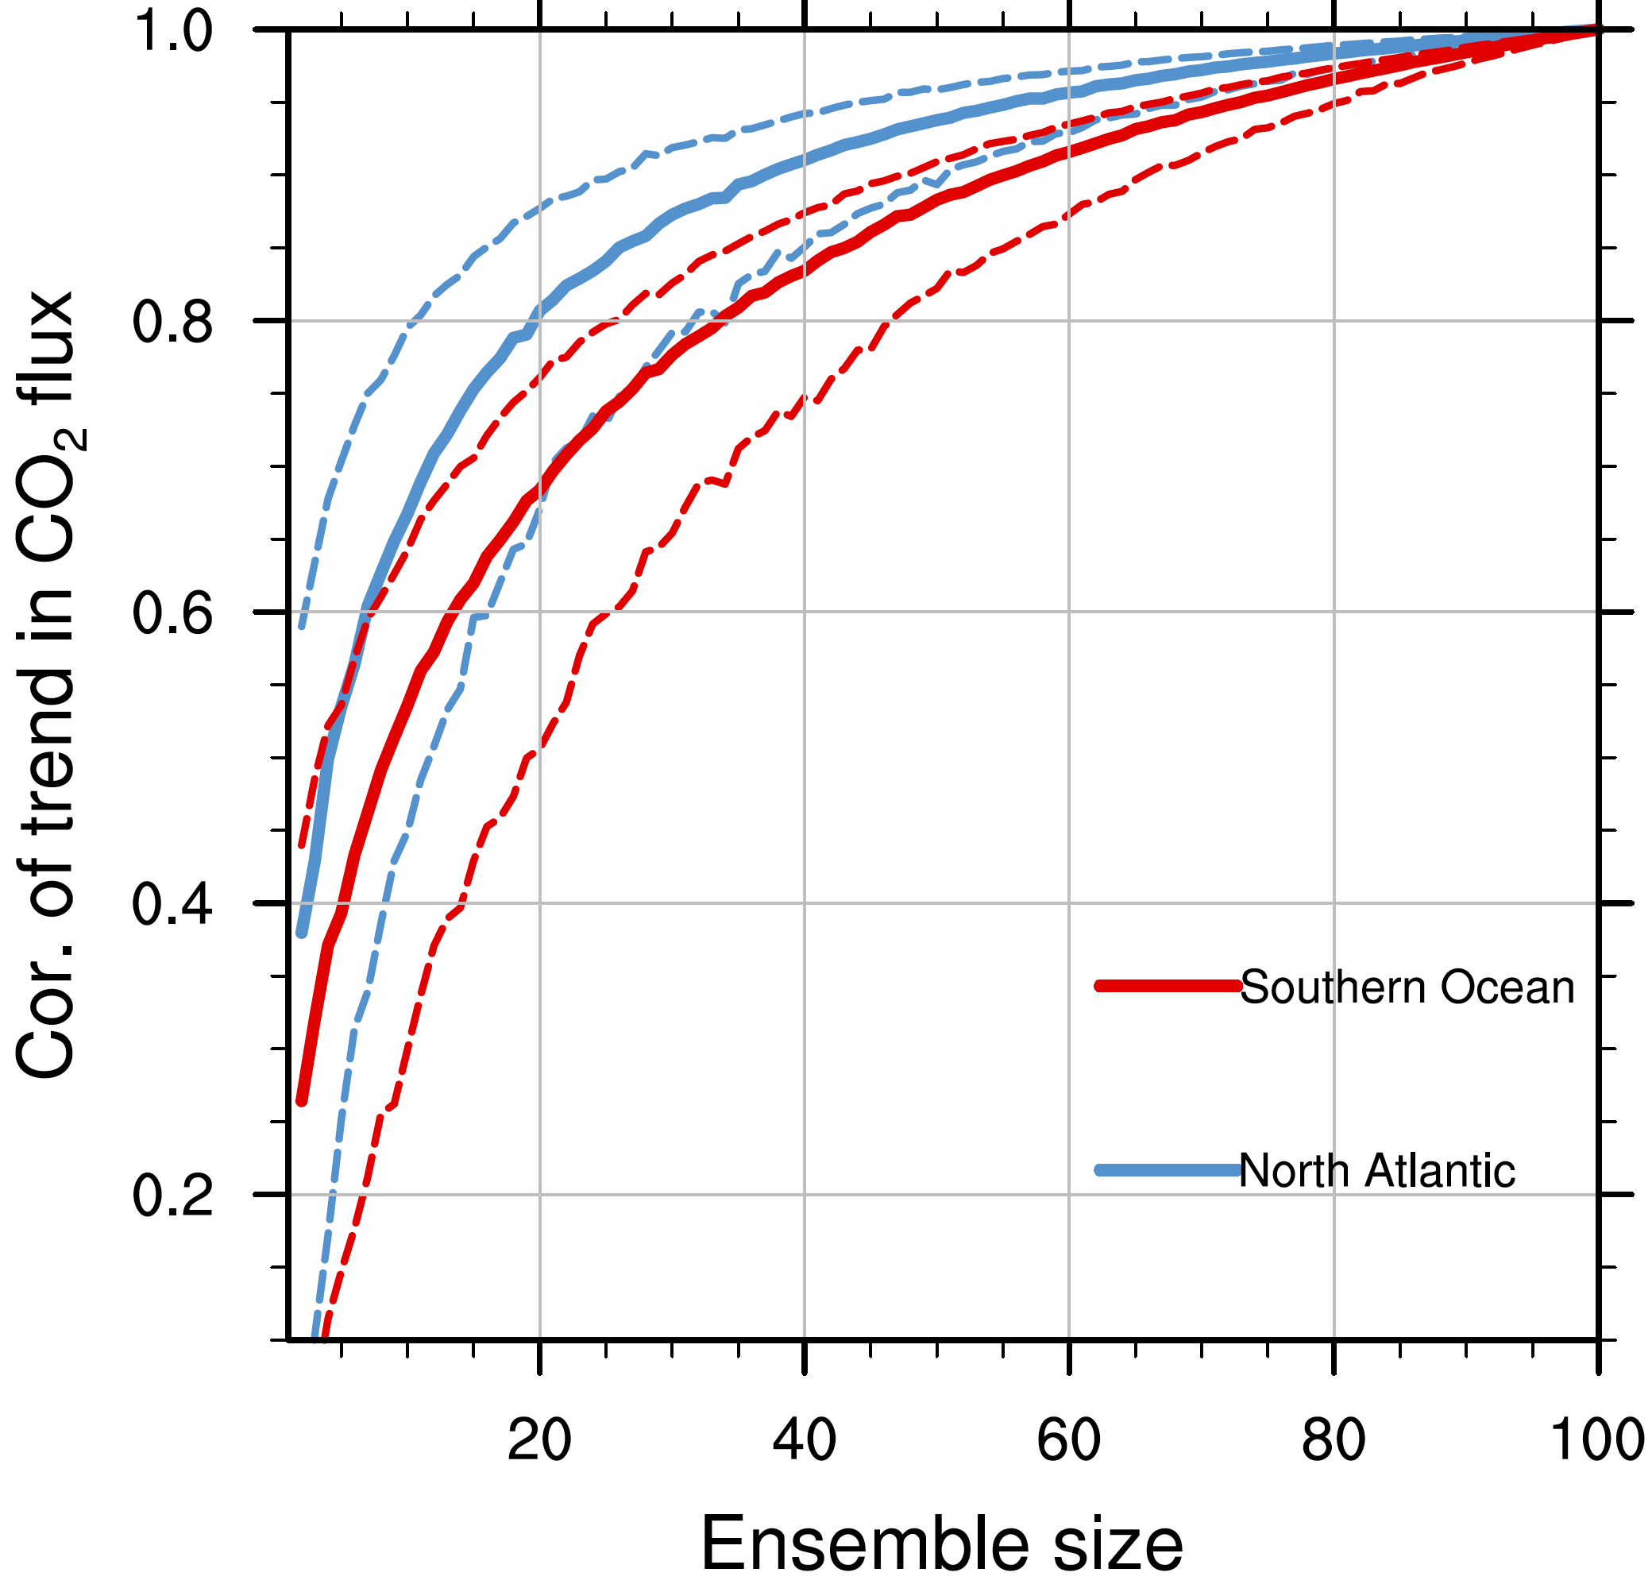 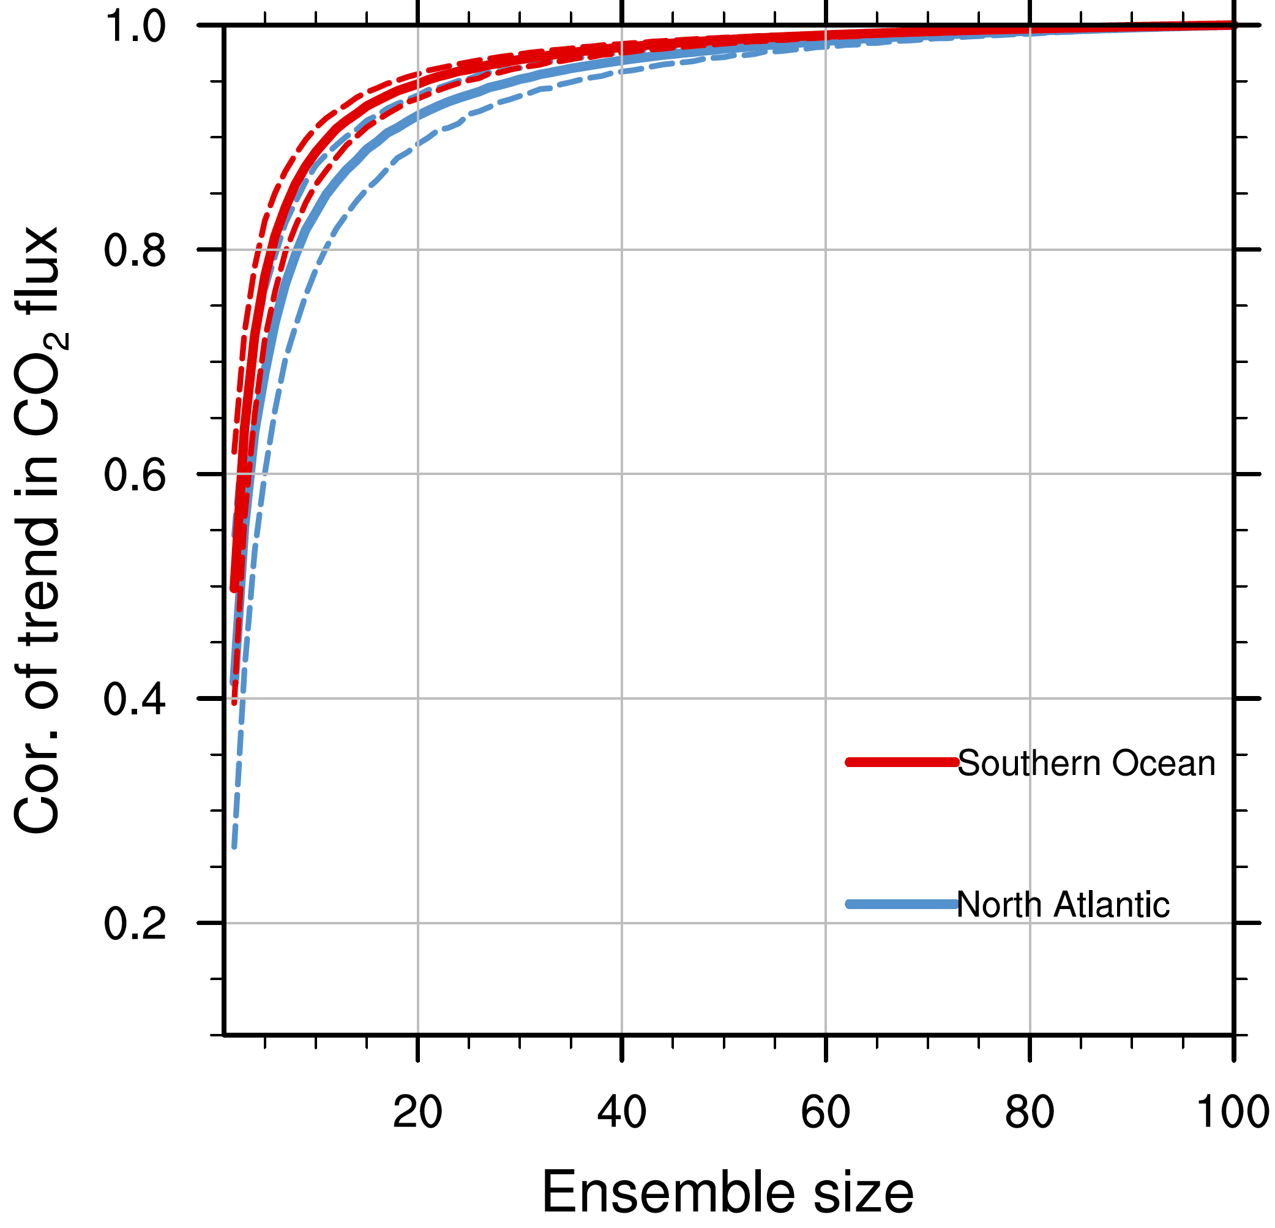

**(b)**

**(a)**

Fig 3. Spatial correlation of mean trend in CO2 flux at different ensemble size against 100-member ensemble mean trend (a). (b) The same as (a), but for standard deviation of trends. For each ensemble size we calculate the correlation 1000 times based on different combination of ensembles, the solid lines show the mean results and the dashed lines show 90% confidence interval.

5 Future evolution of ocean carbon sink

The large ensemble of simulations enables us to estimate the internal variability of the carbon cycle and hence the climate change, which provides a reference for future prediction and projection. Large internal variability of both temperature and CO2 flux is found in future scenario simulations (Fig. 4). Here we explore how large the internal variability of the global mean temperature is in near future under the context of 1.5°C global warming target (Fig. 4a). Several ensemble members produce global warming relative to preindustrial larger than 1.5°C around 2030s, while still ensemble member (blue curve in Fig. 4a) produce a warming below 1.0°C by 2030. The average range of maximum and minimum global temperature warming is 0.66°C from 2026-2035. The average range of maximum and minimum global CO2 flux anomaly is 0.76 PgC yr-1 during the period 2026-2035. Given the large internal variability of both global temperature and global ocean carbon uptake change, it requires rigorous mitigation of emission to maintain the 1.5°C even 2.0°C global warming target.

Actually, the internal variability does not stay the same magnitude in correspondence to increasing of anthropogenic emissions. The oceanic carbon uptake increases as the atmospheric CO2 concentration increases in the idealized 1% per year increase atmospheric CO2 concentration simulations (Fig. 4c, black and grey curves). The internal variability (expressed as standard deviation) of oceanic carbon uptake increases with its magnitude itself in the idealized 1% per year increase atmospheric CO2 concentration simulations (Fig. 4c, red curve). From the spatial distribution of the spread changes, we find that the large increase of spread locates in major C uptake regions such as the North Atlantic and the Southern Ocean (figure omitted).

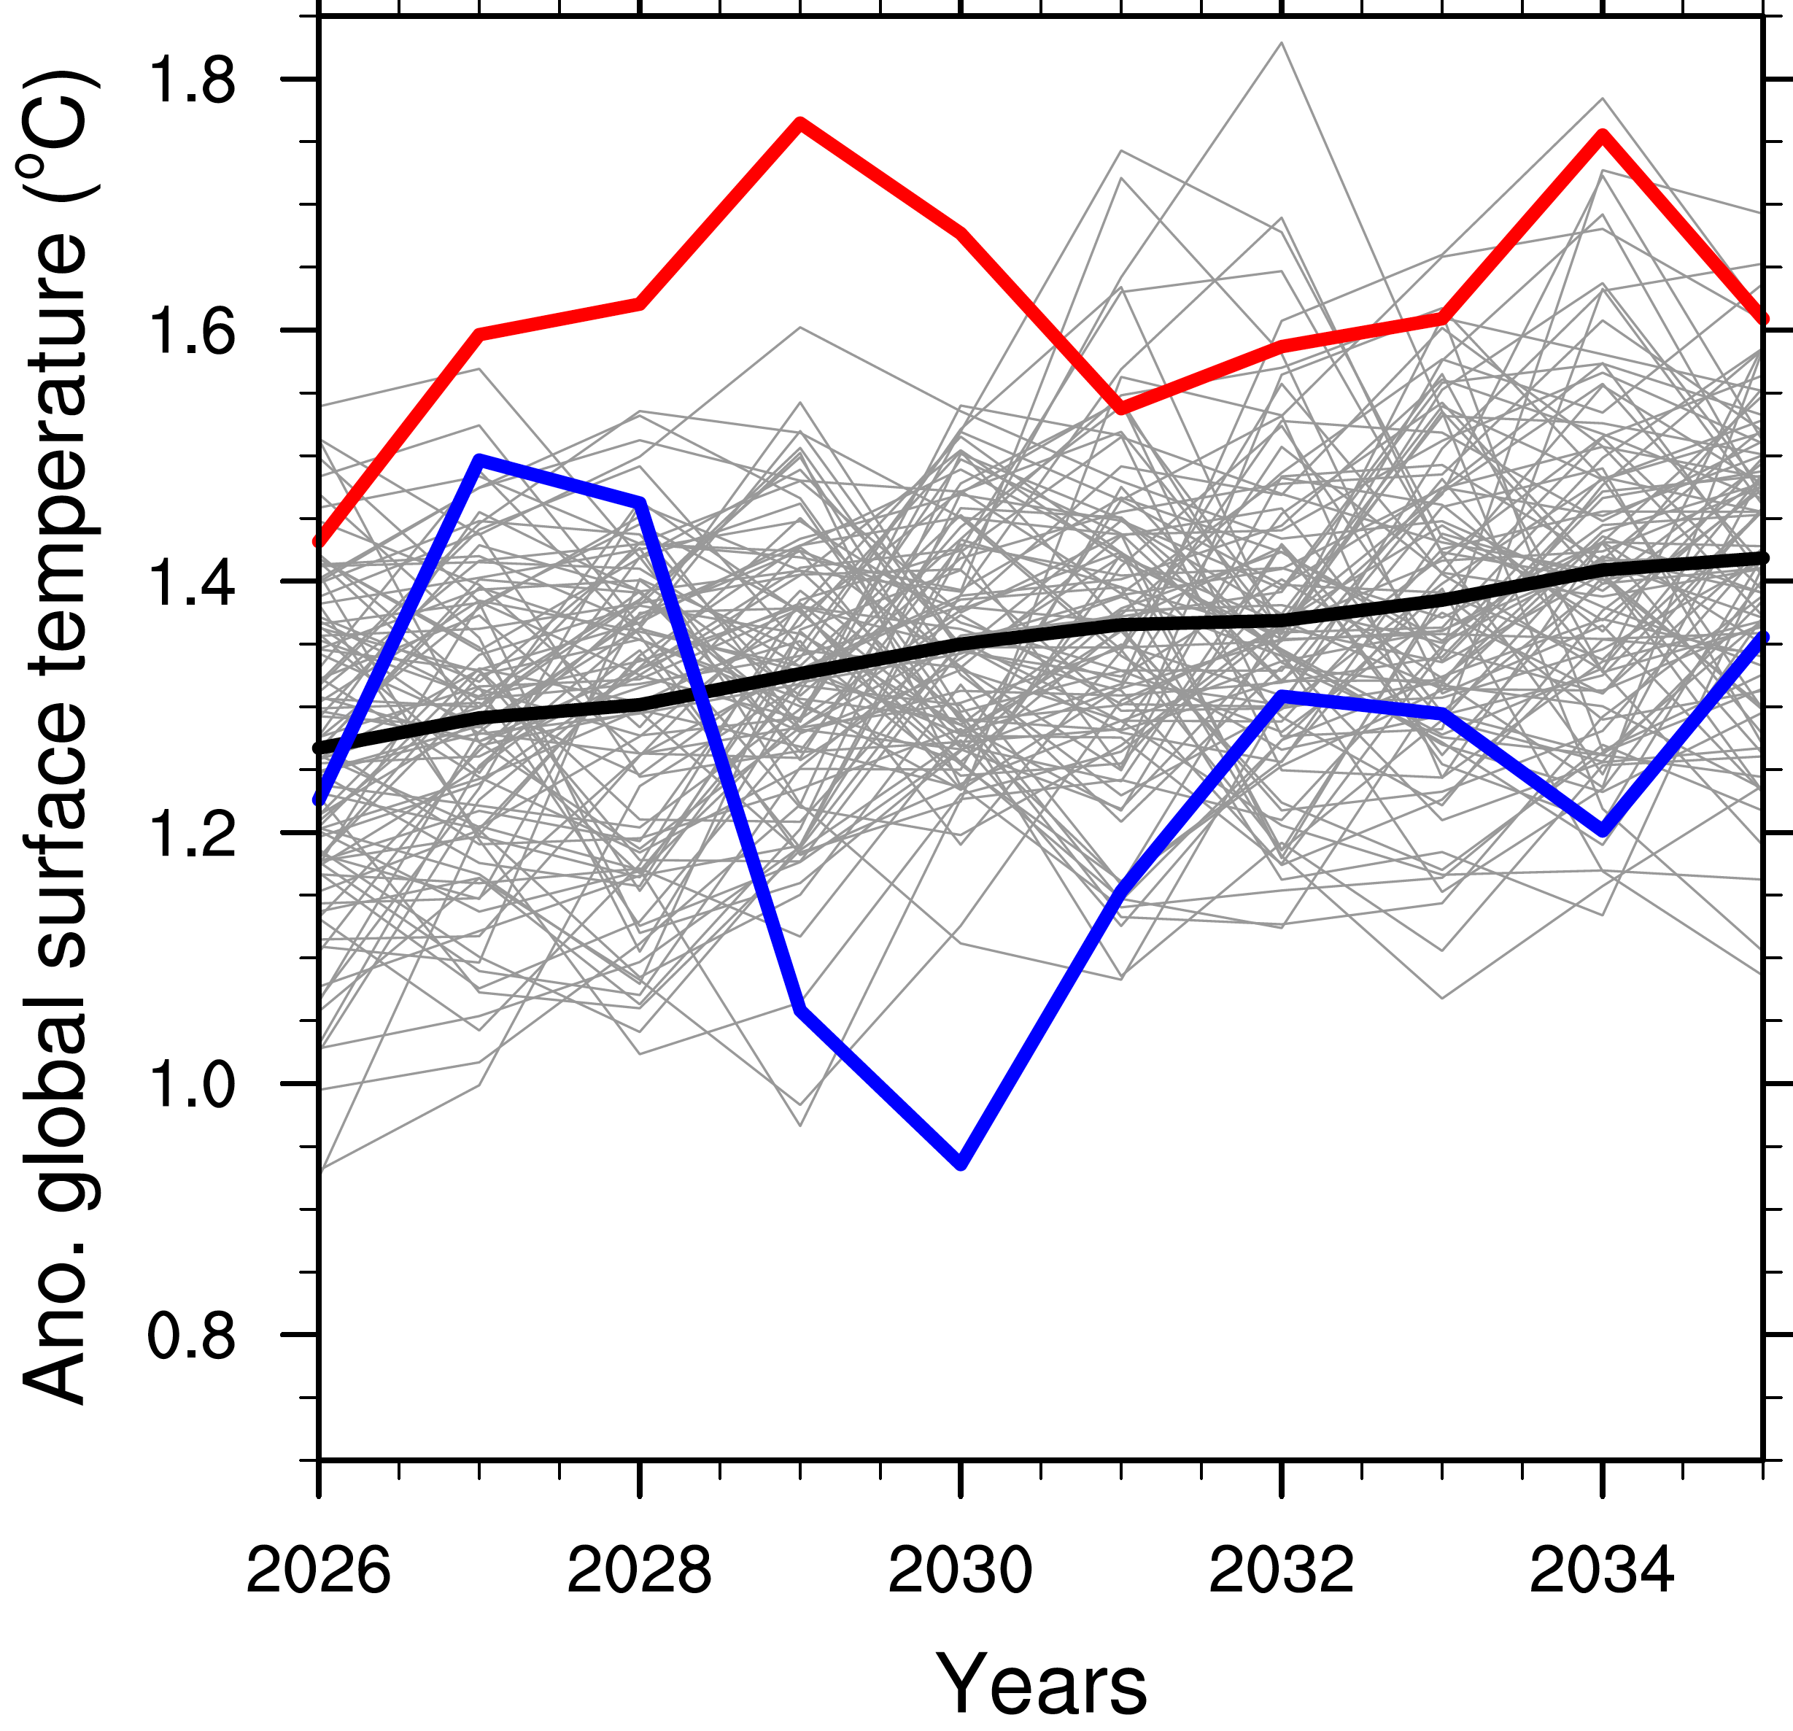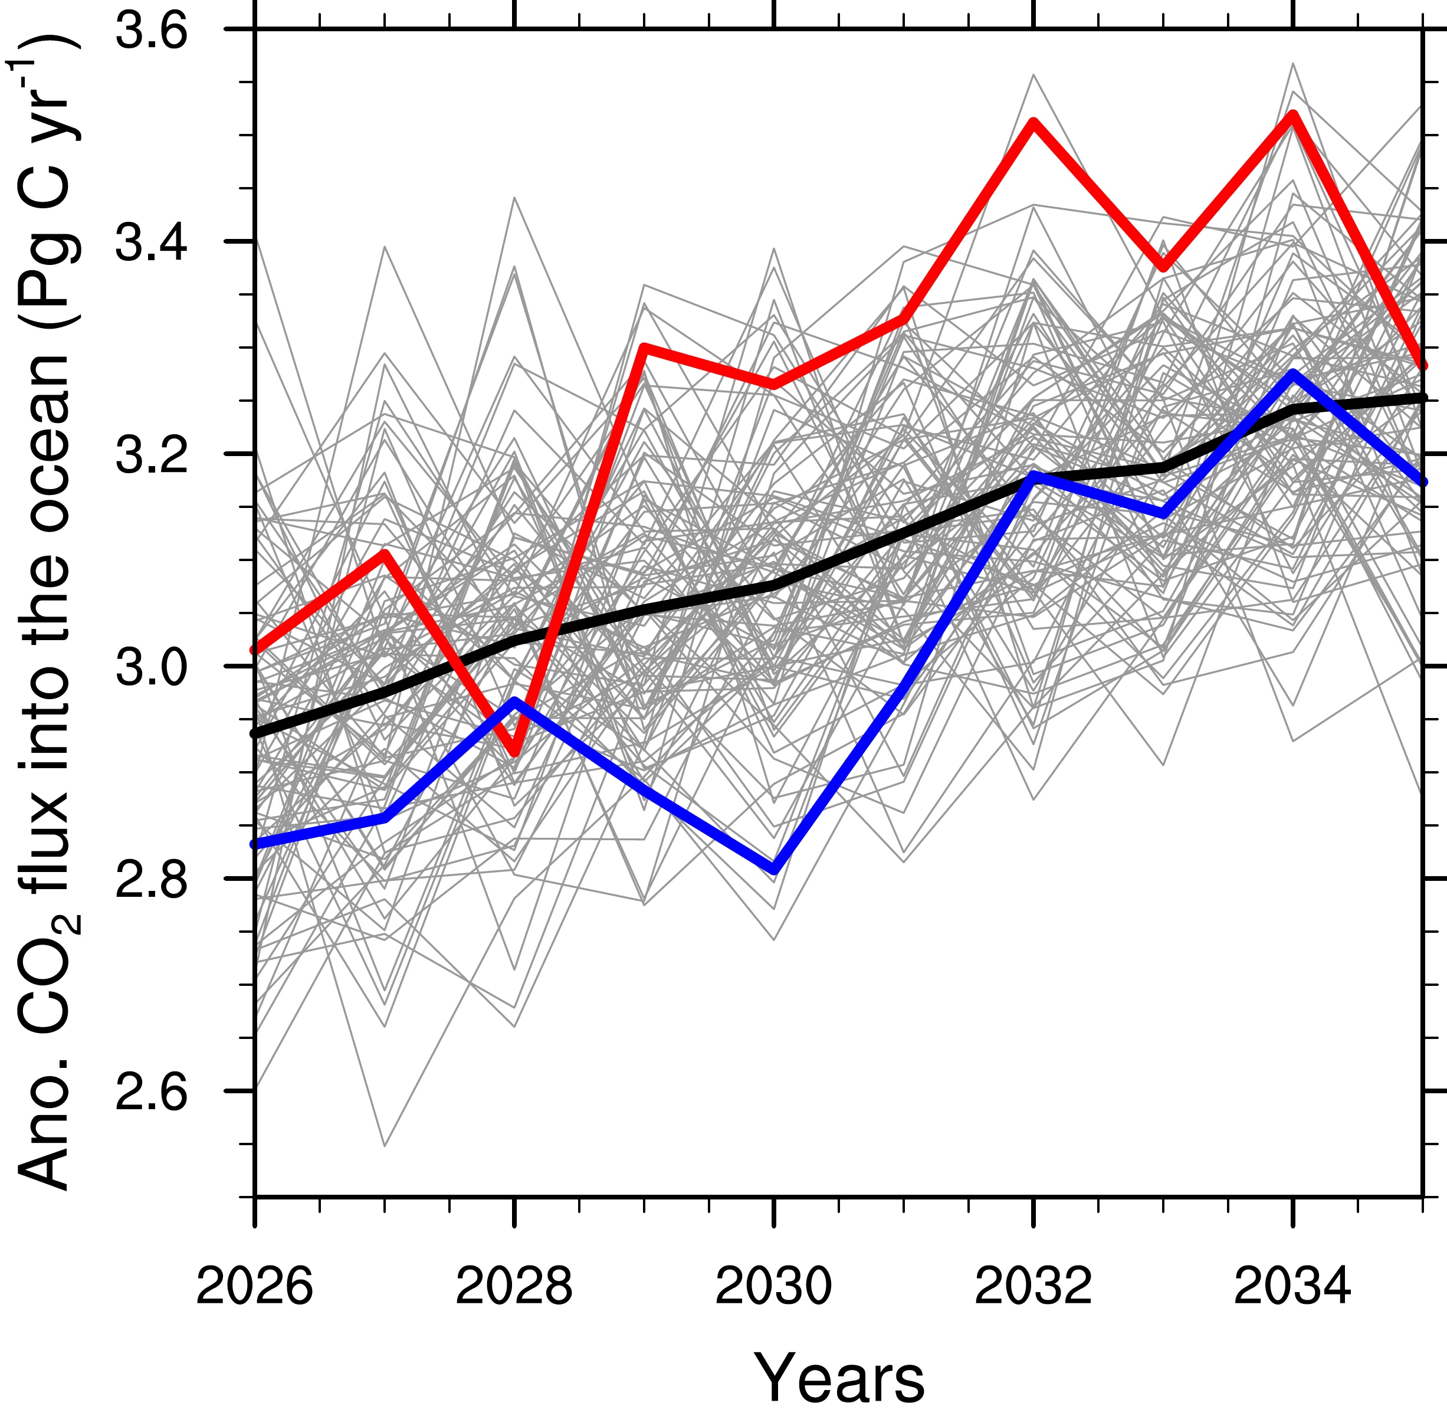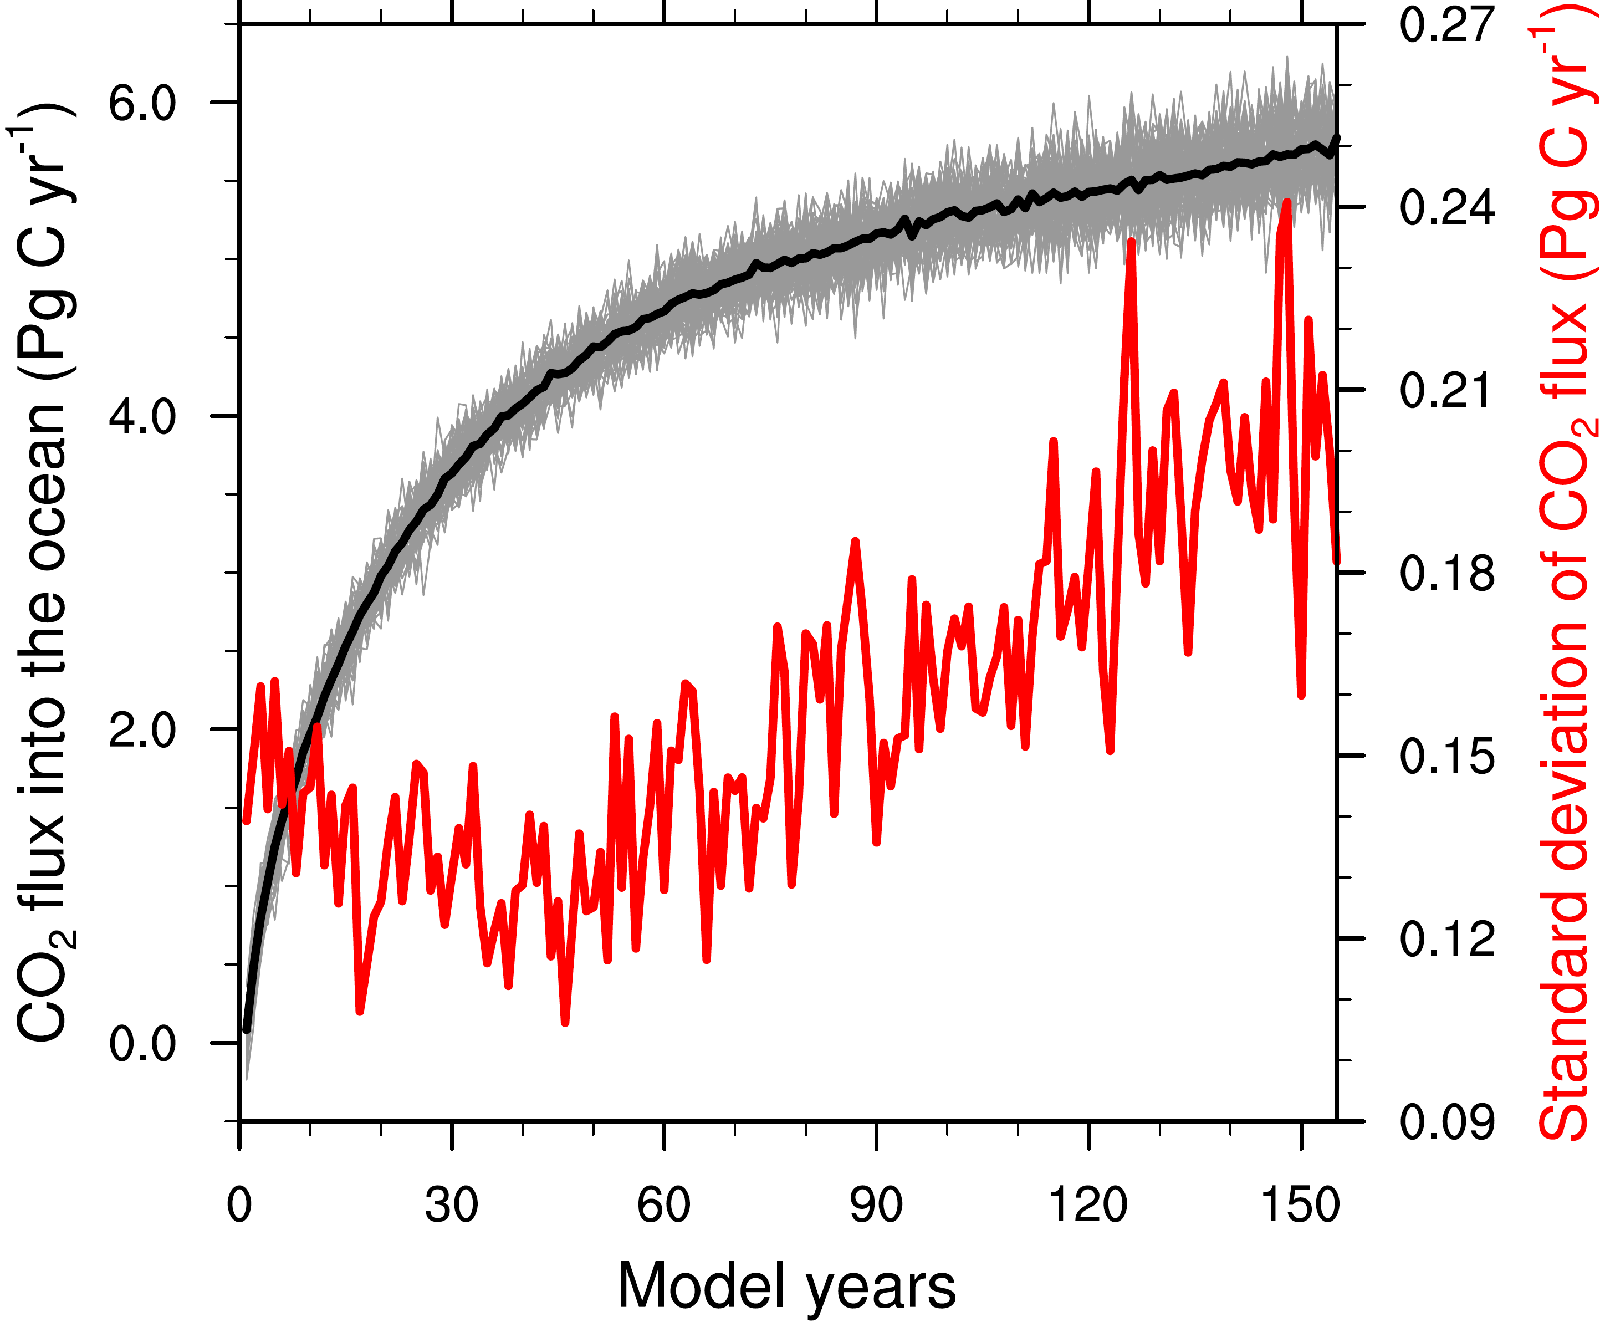

**(a)**

**(b)**

**(c)**

Fig 4. Imminent evolution of global surface temperature anomaly and CO2 flux anomaly under RCP4.5 scenario relative to pre-industrial states (a-b). Evolution of CO2 flux from idealized 1% per year increase atmospheric CO2 concentration simulations (c). The grey lines show individual ensemble members and black thick line shows ensemble mean. Red and blue lines in (a) and (b) highlight 2 ensemble members with large anomalies. The red line in (c) shows the standard deviation of ensemble members along with model years.

6 Summary and conclusions

MPI-ESM large ensemble simulations produce large internal variability of the ocean carbon sink. Various ensemble members produce both increasing and decreasing trends of oceanic carbon uptake over the past decades, which is also expected from observations.

We explore how many ensemble members is necessary to reproduce forced trend of CO2 flux (i.e., 100 ensemble member mean trend). Due to a larger internal variability, the Southern Ocean requires larger ensemble size than the North Atlantic to mimic the forced trend pattern.

Large internal variability of both temperature and CO2 flux is found in future scenario simulations. In idealized runs, the internal variability of oceanic carbon uptake increases along with the increase of atmospheric CO2 concentration.

Acknowledgments

We acknowledge funding from the Federal Ministry of Education and Research in Germany (BMBF) through the research programme ‘MiKlipII’ (FKZ: 01LP1517B). Thanks to Luis Kornblueh, Jürgen Kröger, Michael Botzet for making the large ensemble simulations available. The simulations were performed at the Swiss national supercomputing center (CSCS) and the German Climate Computing Center (DKRZ). Primary data and scripts used in the analysis of this study are archived by the Max Planck Institute for Meteorology and can be obtained by contacting publications@mpimet.mpg.de.

References

Bakker, D. C. E., et al. (2014), An update to the Surface Ocean CO2 Atlas (SOCAT version 2), *Earth Syst. Sci. Data*, *6*, 69-90.

Deser, C., A. S. Phillips, M. A. Alexander, and B. V. Smoliak (2014), Projecting North American Climate over the Next 50 Years: Uncertainty due to Internal Variability, *Journal of Climate*, *27*(6), 2271-2296.

Ilyina, T., K. Six, J. Segschneider, E. Maier-Reimer, H. Li, and I. Núñez-Riboni (2013), The global ocean biogeochemistry model HAMOCC: Model architecture and performance as component of the MPI-Earth System Model in different CMIP5 experimental realizations, *J. Adv. Model. Earth Syst.*, *5*, 287-315.

Jungclaus, J. H., N. Fischer, H. Haak, K. Lohmann, J. Marotzke, D. Matei, U. Mikolajewicz, D. Notz, and J. S. von Storch (2013), Characteristics of the ocean simulations in the Max Planck Institute Ocean Model (MPIOM) the ocean component of the MPI-Earth system model, *Journal of Advances in Modeling Earth Systems*, *5*(2), 422-446.

Landschützer, P., N. Gruber, D. C. E. Bakker, and U. Schuster (2014), Recent variability of the global ocean carbon sink, *Global Biogeochemical Cycles*, *28*(9), 927-949.

Landschützer, P., et al. (2015), The reinvigoration of the Southern Ocean carbon sink, *Science*, *349*(6253), 1221-1224.

Le Quéré, C., et al. (2009), Trends in the sources and sinks of carbon dioxide, *Nature Geoscience*, *2*(12), 831-836.

Le Quéré, C., et al. (2015), Global Carbon Budget 2015, *Earth System Science Data*, *7*(2), 349-396.

McKinley, G. A., D. J. Pilcher, A. R. Fay, K. Lindsay, M. C. Long, and N. S. Lovenduski (2016), Timescales for detection of trends in the ocean carbon sink, *Nature*, *530*(7591), 469-+.

Rödenbeck, C., et al. (2015), Data-based estimates of the ocean carbon sink variability first - results of the Surface Ocean pCO(2) Mapping intercomparison (SOCOM), *Biogeosciences*, *12*(23), 7251-7278.

Schuster, U., and A. J. Watson (2007), A variable and decreasing sink for atmospheric CO2 in the North Atlantic, *Journal of Geophysical Research-Oceans*, *112*(C11).

Stevens, B. (2015), Rethinking the Lower Bound on Aerosol Radiative Forcing, *Journal of Climate*, *28*(12), 4794-4819.

Takahashi, T., S. Sutherland, and A. Kozyr (2014), Global ocean surface water partial pressure of CO2 database: Measurements performed during 1957–2013 (Version 2013), *ORNL/CDIAC-160*, NDP-088(V2013), Carbon Dioxide Information Analysis Center, Oak Ridge National Laboratory, US Department of Energy, Oak Ridge, Tennessee.

Ting, M., Y. Kushnir, R. Seager, and C. Li (2009), Forced and Internal Twentieth-Century SST Trends in the North Atlantic, *Journal of Climate*, *22*(6), 1469-1481.